**In the name of Allah, the Merciful**

Shear yield stress of connections​

Table of contents

Check 2 ​​

Chapter 1 Introduction  3

1-1Introduction  3

1-2 Statement of Problem 4 ​​

1-3 The necessity of the issue 4

Chapter Two Research Background 5 ​​

1-1 Introduction  5

1-2Research  7

Chapter 3 Implementation and Simulation 10​​​​​

1-1Introduction  10

11 software

1-3 Geometry  Design 11

1-4 meters or 15  meters

1-5 Brahman  19

1-6 Mesh  20

1-7 Loading  23

Chapter 4 Simulation Results 24 ​​​​

1-1Introduction  24

1-2 Stress and bending  contour diagram 25

1-3 Stress Diagram  32

1-4 Bending diagram  33

Chapter Five Conclusion 33 ​​​​

1-1Introduction  33

1-2 Conclusion 34​​​​​

Resources  35

# Abstract

Shear mechanical properties of rock joints in the evaluation of the stability and safety of rock structures , including slopes ,​​​​​​ Connections and tunnels are very important . The yield stress acts as a pivotal point that distinguishes the linear and nonlinear mechanical properties of connections . Given its importance in risk and safety assessment , this​​​​​​​​​​​​​​​​​​​​​ The research first provides a general overview of the common methods for identifying the yield stress . Then , a new displacement based on the displacement reduction factor is proposed and systematically investigated . A comparison between the proposed method and existing methods based on experimental cross - sectional data shows that the former method is more skilled in accurately determining the yield stress without mental interference . Finally , this innovative method is applied to estimate the effects of external environmental factors on the yield stress of rock joints .​​​​​​​

Keywords

**Steel mechanics ; Shear tests ; Yield strength ; Peak stress ; Steel connections​​**

# Chapter 1 Introduction

## 1-1Introduction

Due to the specificity of welding processes , the mechanical properties of welded joint materials , especially the yield strength , are unevenly distributed , and there are also a large number of micro cracks , which seriously affect the safety performance of welded joints . In this study , to analyze and analyze the effect of uneven distribution of yield strength on the crack propagation path of welded joints , other mechanical properties and residual stresses of welded joints are ignored . In the finite element software ABAQUS , the finite element XFEM has been used. To investigate the stress state in the connections of double-sided reinforced composite steel slabs , this study conducted static load tests on composite steel slabs. The primary focus was on analyzing and analyzing the effects of lap reinforcement length and section height in the connections on the load - bearing capacity , deformation behavior . The experimental results showed that increasing the lap reinforcement length and section height in the connections significantly It increases the overall stiffness and bending capacity of composite slabs , increasing the load - bearing capacity by up to 92.3 % .​​​​ and Reduction Deviation Up to 40.2 % . Plus On This is it, A finite element model was used to simulate the mechanical behavior of composite slabs and the results were compared with experimental data and showed a margin of error of 10 % . Based on the validated finite element model , this study further investigated the key factors affecting the stress performance in the connections of double - sided steel composite slabs and their impact patterns . Finally , this paper proposes a simple formula for calculating the bearing capacity of composite slabs , which enables rapid estimation of slab performance , providing theoretical support and practical guidance for structural engineering and construction methods .​​​​​​​​​​​​​​​​​

## 1-2 Statement of the problem

Broken steel piles are often characterized by extensive and complex steel connections , which have a significant impact on their mechanical behavior . Numerous geotechnical engineering applications , including , but not limited to , steel foundations , mining operations , bridge piers , and tunneling projects , have shown that shear failure along these connections leads to serious structural instability . Many recorded seismic disasters , such as landslides , steel cracking caused by slippage , and tunnel collapse , are caused by shear failure of steel connections .​​​​​​ Therefore , extensive and intensive studies on the shear strength characteristics of steel connections are of great theoretical and practical importance for ensuring engineering safety and preventing geological disasters .​​​​​​​​​​​​​​​​​​​​​

## 1.3 The necessity of the issue

As a vital element in the construction industrialization , prefabricated steel structures have been continuously developed with the support of national and local government policies and market promotion . Among these structures , composite slabs have been widely used due to their ease of construction and high degree of industrialization . A composite slab is divided into two parts along its thickness : the lower part and the upper part .​​​​​ A base is made of prefabricated steel , while the upper part is made of cast - in - place steel . Due to structural imperfections , ensuring that the steel on both sides of the composite joint works together and carries the loads in a coordinated manner is very important for the design of composite slabs . Therefore , it is necessary to study the capacity and stress transfer mechanism in prefabricated composite slab joints .

# Chapter Two: Research Background

## 1-1Introduction

Many researchers have studied the shear deformation process of steel joints through various approaches and have obtained abundant results [ 21,22,23,24,25,26,27,28,29,30,31 ] . At present , there are three main categories of research methods for analyzing the shear mechanical properties of steel joints : physical model experiments ( laboratory and field experiments ) , numerical simulations , and theoretical analyses [ 32,33,34,35,36,37,38 .​​​​​​​​​​​​​​​​​​​​​​ ,39,40,41,42]. Non- uniform oscillation The unevenness of the interface, the uneven contact between two walls , the elastic deformation of uneven bodies , and the gradual deterioration It often results in the shear mechanical behavior of steel joints that alternately exhibit linear and nonlinear properties [ 43,44 ] . Yield stress , peak strength , and residual stress threshold strength are key to classifying these properties . In terms of peak strength , dozens of models have been developed successively since Patton introduced the shear expansion effect in the standard Mohr -Coulomb has been introduced to create a bilinear resistance model [ 45,46,47]. The Joint Coefficient of Resistance - Joint Compression Strength ( JRC - JCS) model proposed by Barton and Choubi [ 48] has gained wide acceptance among researchers and engineers in the field of steel engineering . In addition , it has been explicitly accepted by the International Commission on Steel Mechanics ( ISRM ) [ 49 ] . The residual resistance , also called the ultimate resistance , It is an ideal concept that defines the shear stress at a suitable shear displacement . However , the shear displacement in laboratory tests is limited , making it difficult to obtain the actual residual strength as defined . Therefore , the Commission​​​​​​​​​​​​ ISRM suggests that when the shear displacement reaches 10% of the joint length , the corresponding shear stress can be considered as the residual strength . However , in the case of yield stress , despite the widely accepted definition , its estimation method is still in its infancy because existing predictive methods cannot accurately identify the yield stress . In fact , the safe and efficient design of steel structures ( such as slopes and thrusts ) relies not only on the peak strength but also on the yield stress [ 50 ] . As the stress reaches the yield point , internal damage gradually accumulates .​​​​ Significant plastic deformation occurs along the steel joints , leading to significant nonlinear mechanical properties , such as a non - linear shear - forming curve and less ductile fracture at the joint surfaces [ 51 ] . Comprehensive studies of the shear stress - displacement behavior of steel joints over the past half century have shown that relying solely on peak strength is inadequate for evaluating the strength properties of such joints [ 52,53,54,55,56,57 ] . ] .​​ Instead , more emphasis should be placed on determining yield stress , as this can serve as an effective early warning indicator for potential engineering hazards .​​​​​​​​ Therefore , the development of a reliable predictive method for estimating the yield stress is essential [ 58 ] .​​​​

Despite existing research efforts , yield stress has not been comprehensively studied. If the correlation between stress levels and yield stress can be established in laboratory settings , The field test enables accurate assessment and evaluation of the connection stability and damage degree of steel beams . This study aims to present a new method for accurate identification of the shear yield stress . The structure of this research is as follows : Section 2 provides an overview of the existing methods for determining the yield stress and critically evaluates their strengths and limitations . In Section 3 , a new method is presented in a simple and straightforward manner by introducing​​​​​​​​​​​​​​​​​​​​​​​ A displacement reduction factor is proposed for processing shear stress displacement data , eliminating the dependence on elastic parameters . To verify the effectiveness of the proposed method , the results of the new method are compared with existing methods . Section 4 investigates the effect of external environmental factors on the determined yield stress . Finally , Section 5 summarizes the findings and discusses future research directions .​​​​​​​​​​​​​​​​​​​​​​​

## 1-2Research

In direct shear tests , a certain normal stress is applied to the specimen before a shear stress parallel to the bond plane is applied . Figure 1 shows a typical shear stress-displacement curve that consists of two distinct phases : pre - peak and post - peak ( Phase III ). The pre-peak phase can be divided into two sub - phases : sub - phase I which is characterized by linear tension and the sub- stage II , which is characterized by yielding and the boundary point is at the yielding point [ 59 ] . In the linear elastic stage , the shear stress increases linearly with respect to the shear displacement , and the shear stiffness can be determined by calculating the slope of this line . The gaps between the joint surfaces in this stage have a pronounced elastic property . Subsequently, the shear-forming curve enters the yield stage , in which plastic shear displacement begins to occur , the anomalies gradually wear out and break , the shear stiffness decreases significantly , and the hanging side and the head side slide along the joint . Upon reaching the maximum shear stress , the contact plane undergoes significant collapse , which in turn leads to further slip along the joint . The roughness and waviness of the steel joints cause normal displacement , which ultimately leads to expansion . When the shear stress exceeds the bearing capacity of the thin sheets, cumulative damage causes a significant reduction in shear stress , as shown in Figure 1. Here , the present study focuses on identifying the yield point , which plays an important role in determining the changes in the shear mechanical behavior of steel connections . In the past few decades , numerous studies have been conducted to determine the yield point of the shear - forming curve , which can be categorized as follows :

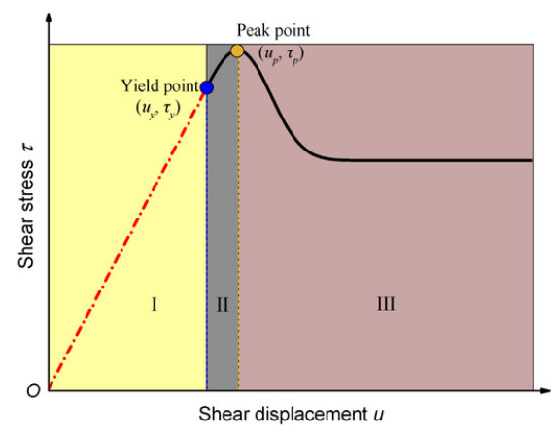

Figure 1. Schematic diagram of the shear stress - shear change curve ( uy and up are the yield displacement and peak shear displacement , respectively ; τy and τp are the yield stress and peak shear stress , respectively ) .​​

(1 ) Experimental methods

According to the results of extensive direct shear tests conducted on rock joints by Goodman [60], it is usually observed that the yield point is in the range of 70 % Up to 90 % Tension peak shear occurs . Using this method , Xiao et al . [61] used a yield point equivalent to 70% of the peak shear stress to extract the analytical A shear - constructive model was adopted . Similarly, Sun et al. [62] reported that the ratio between the yield shear stress and the peak shear stress is approximately 0.85 . From the perspective of shear displacement , One- third of the peak shear displacement is attributed by many researchers to It is considered as a displacement of yield [ 52,53,63,64 ] . Although empirical methods may be suitable for engineering projects , they are very subjective and do not take into account important factors such as lithology and pre - existing defects .

( 2 ) Shear hardening method

pre-peak phase of the shear stress – shear displacement curve of rock joints is usually fitted using a hyperbolic function [ 65] . The following equation was adopted by Koolhaas [ 66 ] to reproduce the pre - peak curve :



where ui is the shear displacement at a given shear stress , m represents the reciprocal of the initial shear stiffness​​ Kst and n are the horizontal asymptotes of the hyperbolic curve . By using equation (1) to fit the experimental data , the initial shear stiffness can be easily extracted . Subsequently , the line from the origin O with a slope Kst originates from the shear stress -displacement curve intersecting at point F , which represents the yield point [ 67 ] , as shown in Figure 2. This method is based on the results of shear tests . However , it is worth noting that the determination of the initial shear stiffness may be inaccurate in cases where the shear stress - displacement curve does not exhibit a hyperbolic shape .

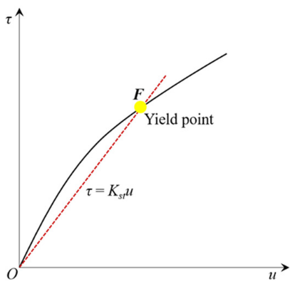

Figure 2. Schematic diagram of a shear hardening method .

# Chapter 3: Implementation and Simulation

## 1-1Introduction

The numerical method used in this paper is FEM for simulating uniaxial tensile deformation . The FE finite element simulation is mainly carried out using the commercial finite element software ABAQUS ( 2023) . The theoretical part mainly includes the strength model and the plasticity constitutive model . The strength model is mainly based on previous works , and the model is built by considering the strengthening effect of two types of sediments . Subsequently , this strategy is used to convert the macroscopic yield stress into the initial flow stress of the single crystal . The plasticity model is mainly used for Description of the strain hardening behavior of materials, for It is used to obtain probable crack initiation locations and to explore the effects of microstructure parameters on mechanical properties .

## 1-2 Abaqus software

This is​ Abaqus/ CAE is a software application used for both modeling , analysis , and visualization of mechanical components and assemblies ( preprocessing ) and for visualization of the results of finite element analysis . A subset of Abaqus / CAE that includes only the postprocessing module can be run independently in the Abaqus / Viewer product .

## 1-3 Geometry design

The desired geometry is designed as the desired shape.

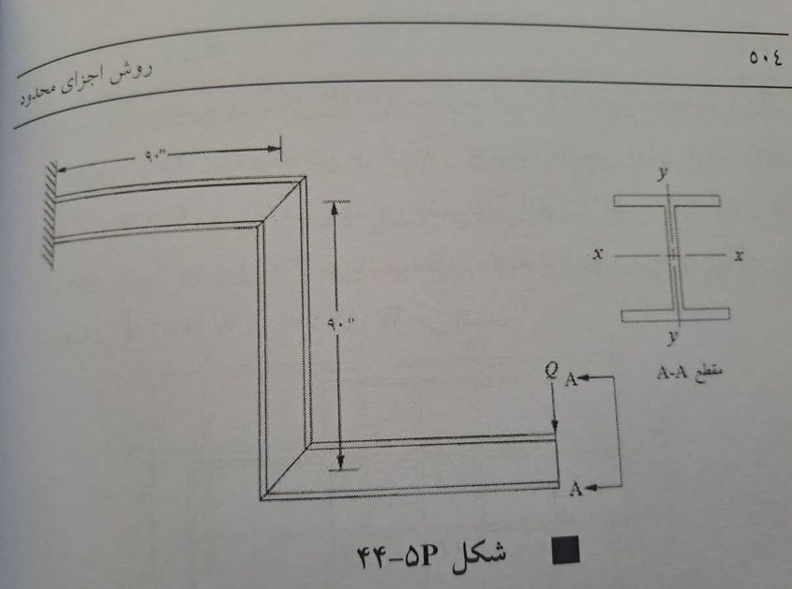

Figure 3-1 Geometry

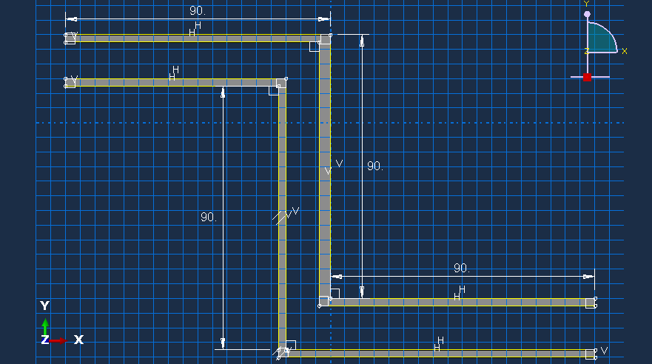

Figure 3-2 Abaqus geometry

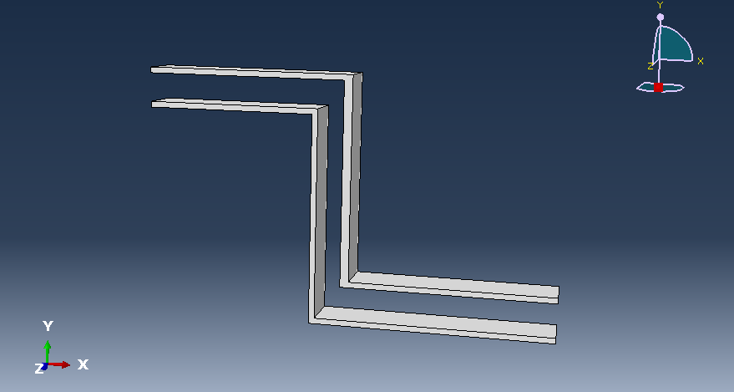

Figure 3-3 Geometry with extrusion

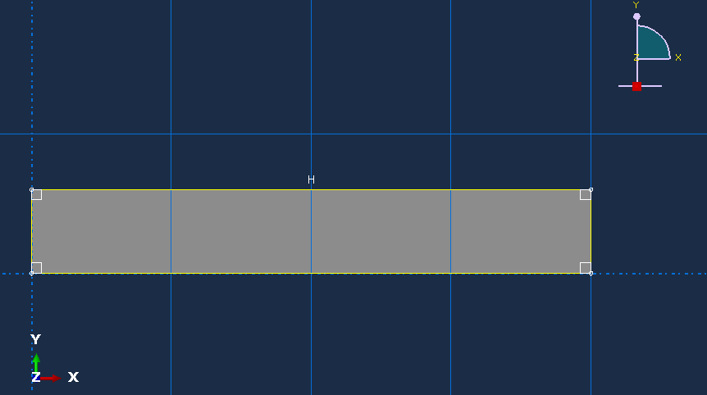

Figure 3-4 Cross-sectional geometry

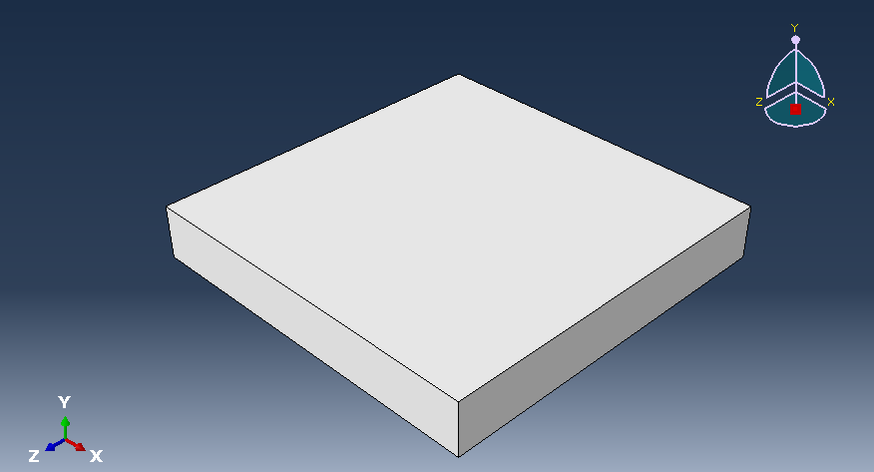

Figure 3-5 Cross-sectional geometry with extrusion

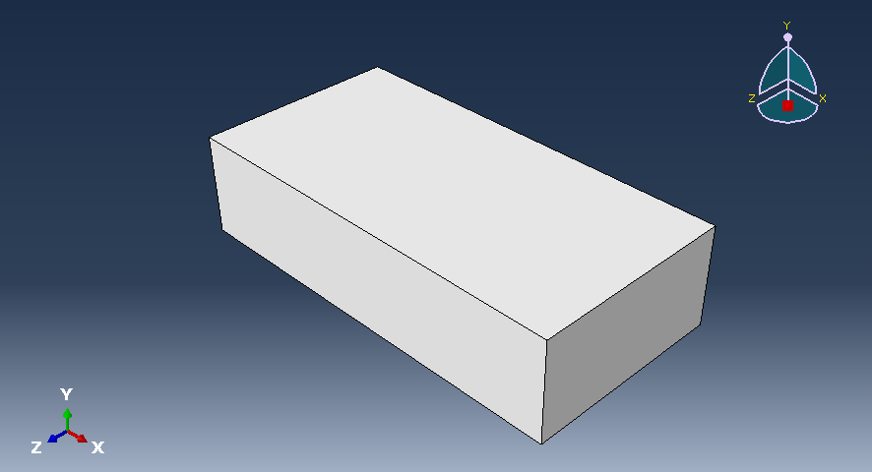

Figure 3-6 Geometry of the support surface with extrusion

## 1-4Material

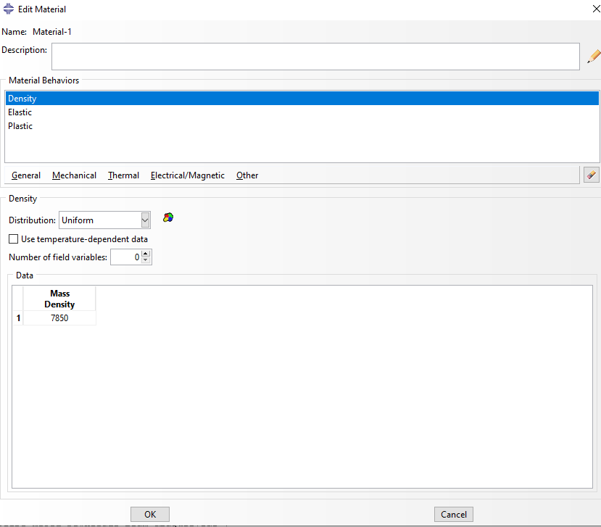

Figure 3-7 Material – Density

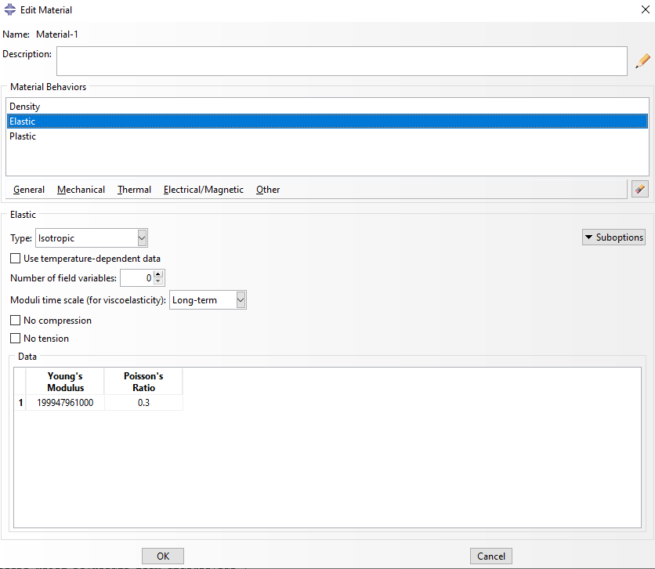

Figure 3-8 Material – Young's modulus and Poisson's stiffness coefficients

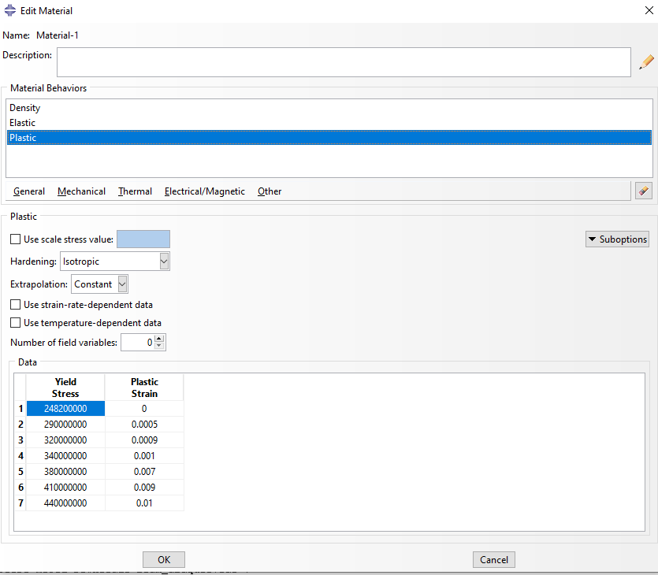

Figure 3-9 Material – Yield stress and plasticity bending

## 1-5 Superposition

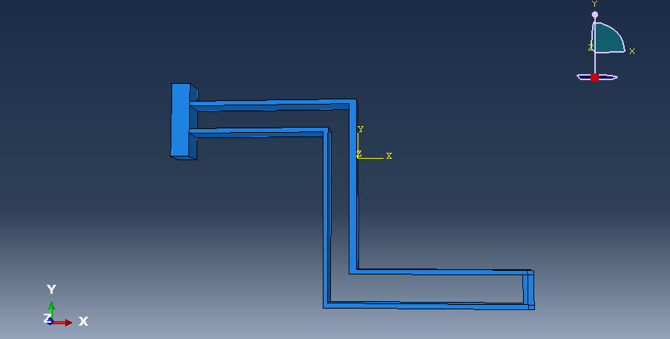

Figure 3-10 Superposition and assembly



Figure 3-11 Time step

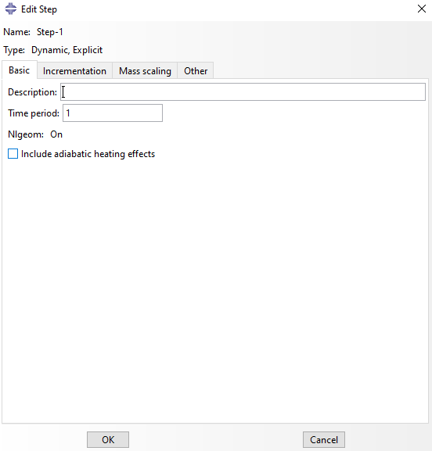

Figure 3-12 Time step

## 1-6 Meshing

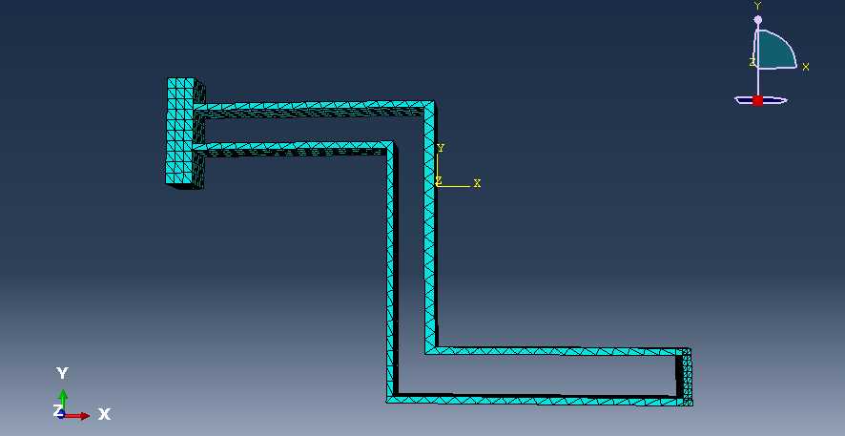

Figure 3-13 Meshing

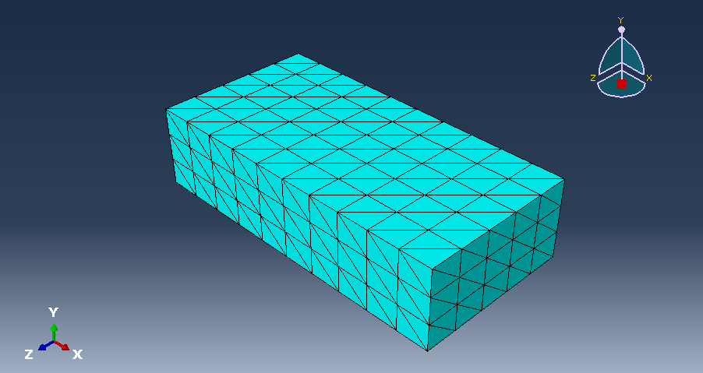

Figure 3-14 Meshing

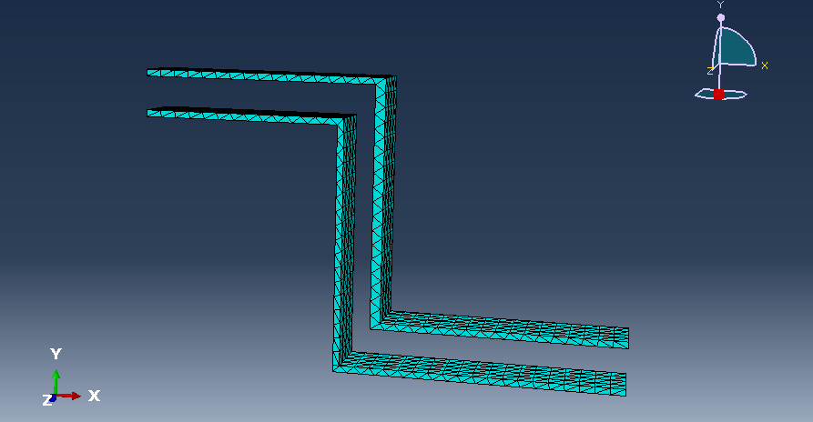

Figure 3-15 Meshing

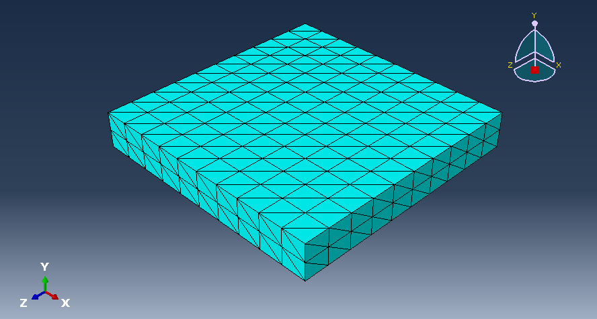

Figure 3-16 Meshing

## 1-7Loading

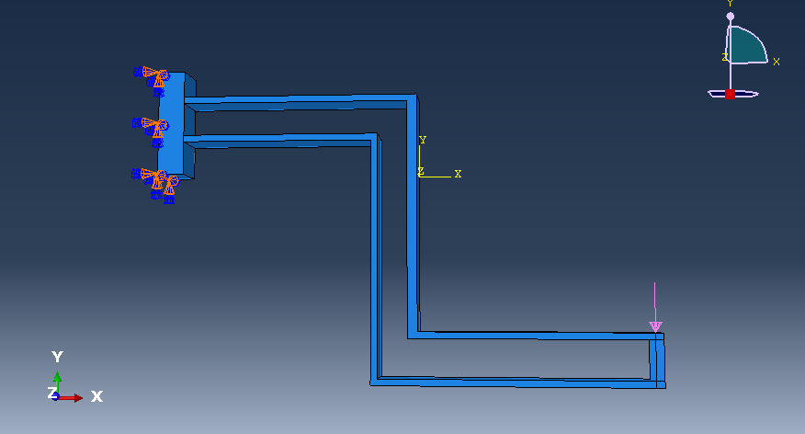

Figure 3-17 Loading the design

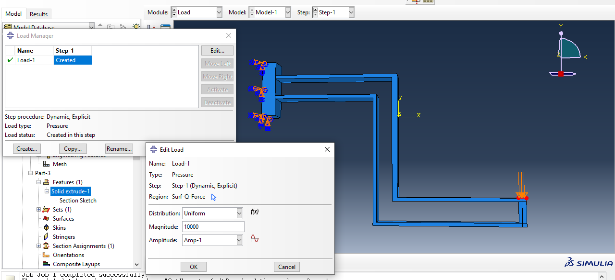

Figure 3-18 Loading the design

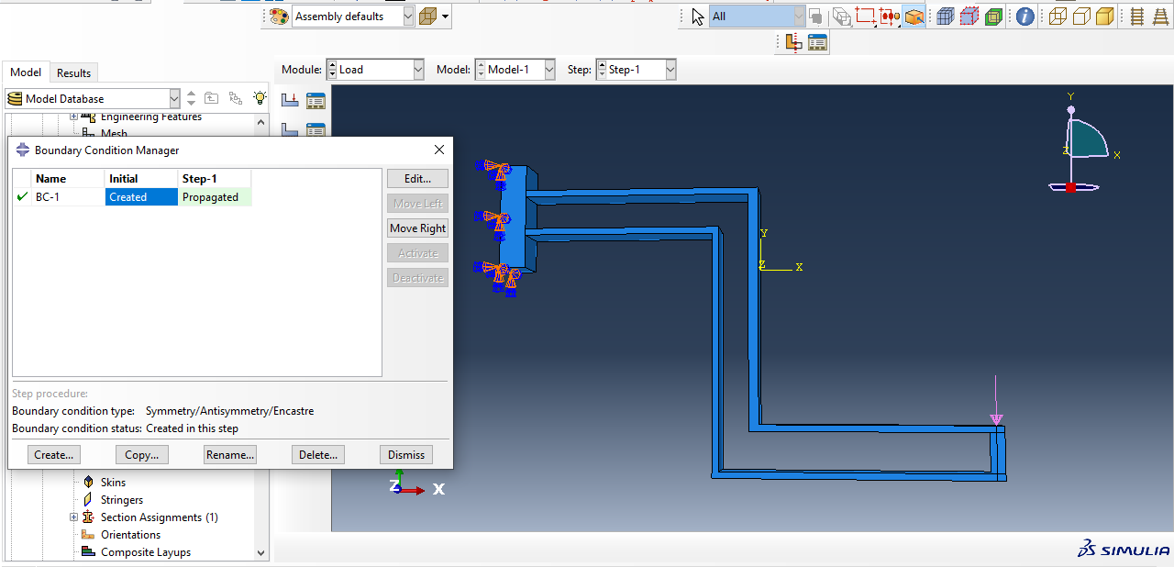

Figure 3-19 Boundary conditions

# Chapter 4 Simulation Results

## 1-1Introduction

It is obvious that domestic and international researchers have proposed various methods for strengthening the joints of composite steel slabs . Accordingly , in order to further optimize the joint performance of composite slabs , this study investigates the stress performance of two-way composite slabs with mesh reinforcement at the joints . The stress state at the joints is investigated from two perspectives . Through experimental research on four composite slabs , along with valid finite element models , the effective factors and variation patterns of the stress performance of two - way composite slabs are simulated . In addition , using steel damage theory , a more in - depth analysis of the stress performance is performed and a coefficient is obtained that shows the effect of the interface on the moment capacity of the reinforcement in the connections . A simple method for calculating the load - bearing capacity is also proposed .​ In summary , this study not only identifies the key factors and mechanisms affecting joint stress , but also provides a scientific theoretical basis for the design and construction of composite slabs and provides new insights and resources for future research on optimizing joint stress performance .​​​​​​​​​​​​​

## 1.2 Stress and bending contour diagram

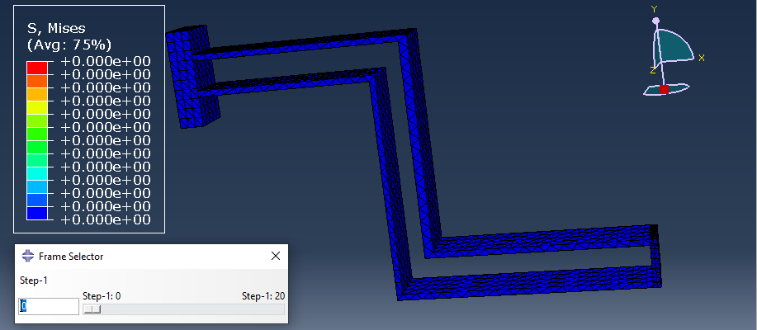

Figure 4-1 Stress contour diagram at step 0

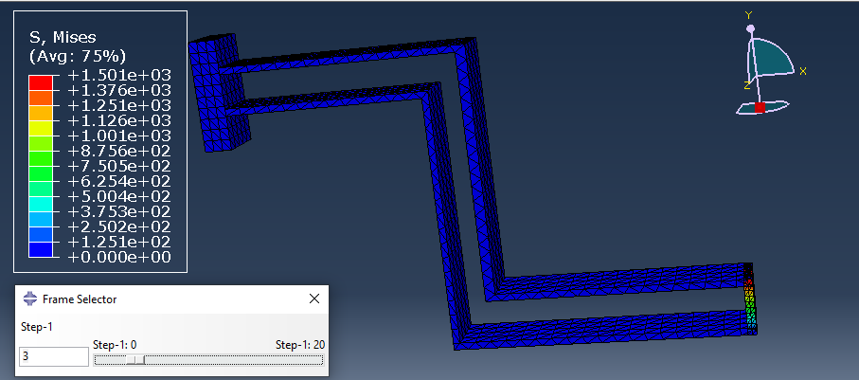

Figure 4-2 Stress contour diagram in step 3

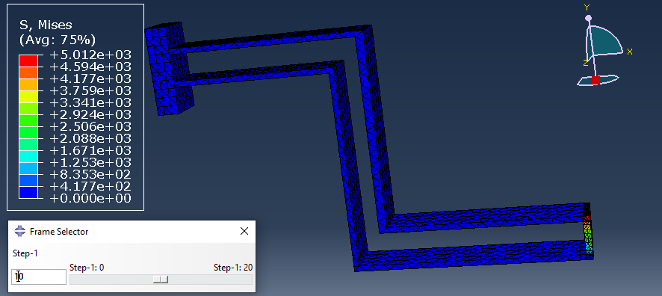

Figure 4-3 Stress contour diagram in step 10

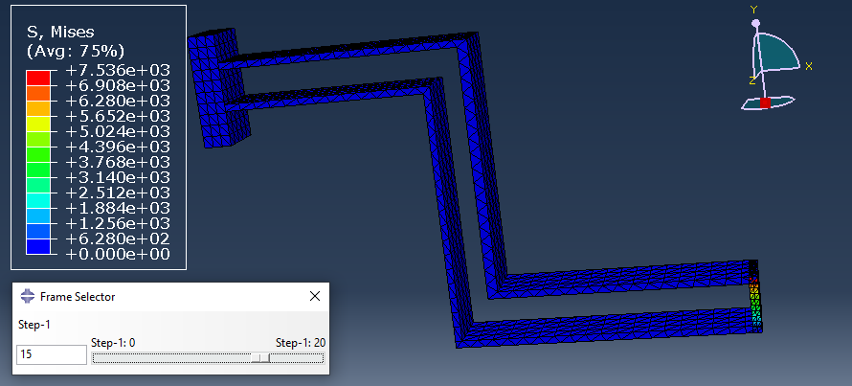

Figure 4-4 Stress contour diagram in step 15

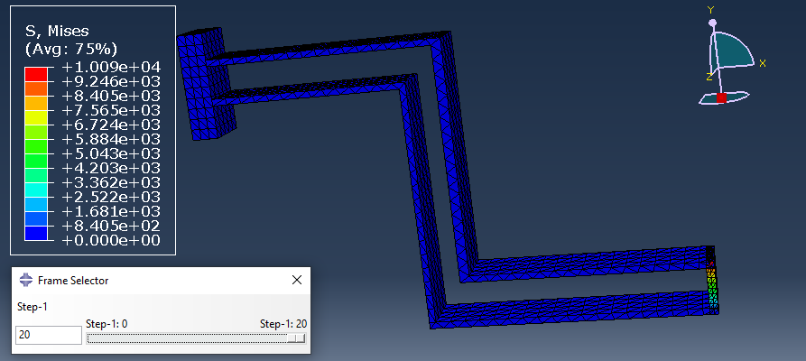

Figure 4-5 Stress contour diagram in Step 20

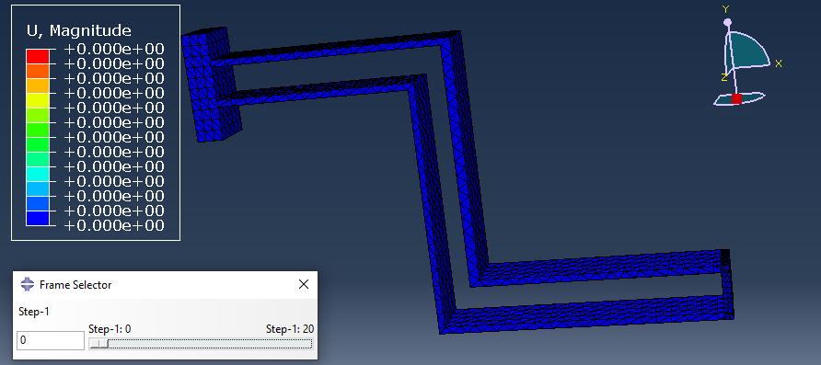

Figure 4-6 Bending contour diagram at step 0

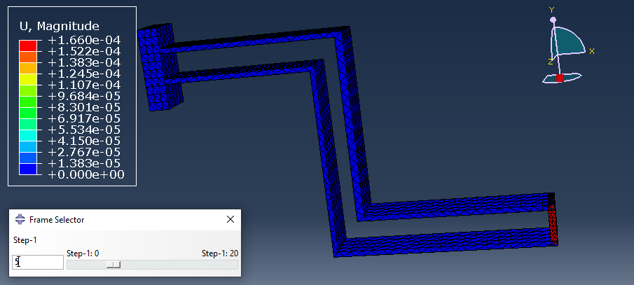

Figure 4-7 Bending contour diagram in Step 5

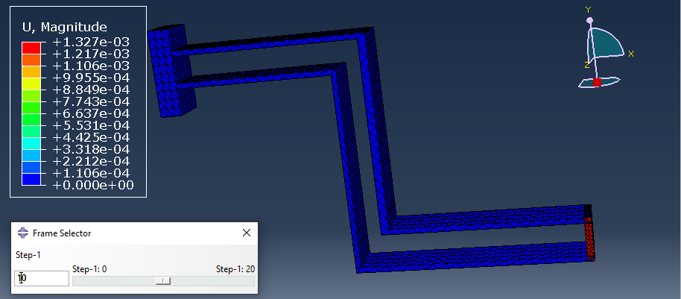

Figure 4-8 Bending contour diagram in step 10

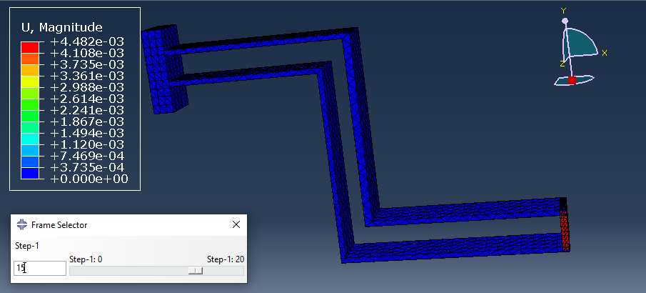

Figure 4-9 Bending contour diagram in Step 15

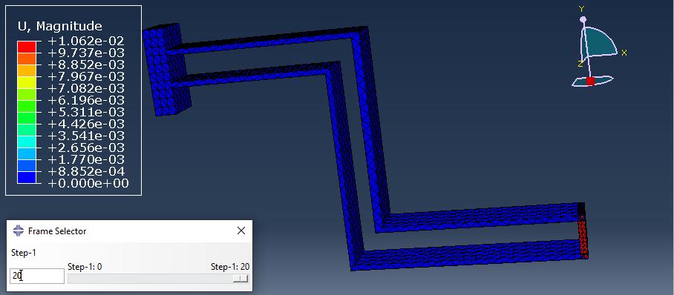

Figure 4-10 Bending contour diagram in Step 20

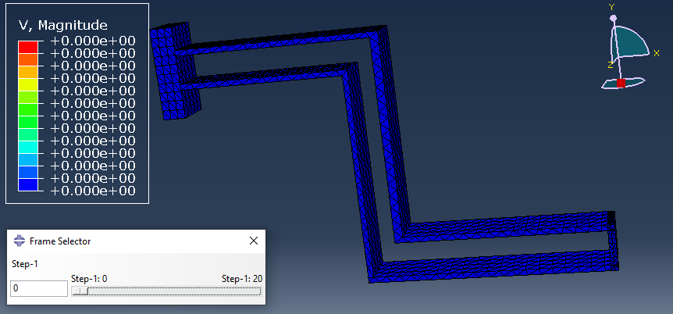

Figure 4-11 Velocity contour diagram at step 0

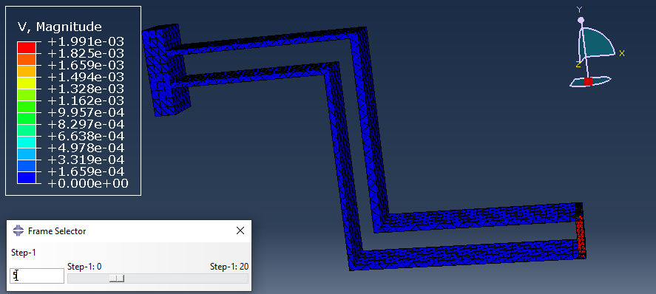

Figure 4-12 Velocity contour diagram in step 5

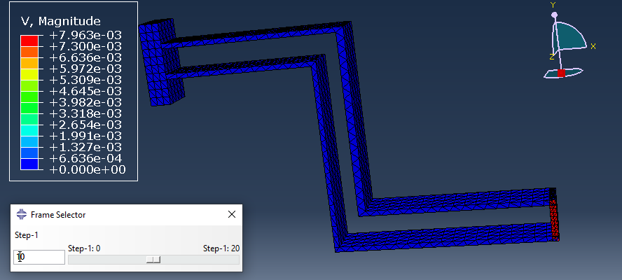

Figure 4-13 Velocity contour diagram in step 10

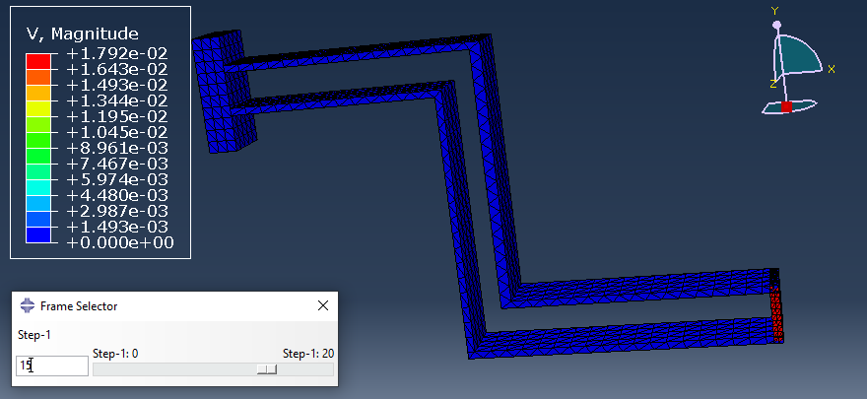

Figure 4-14 Velocity contour diagram in step 15

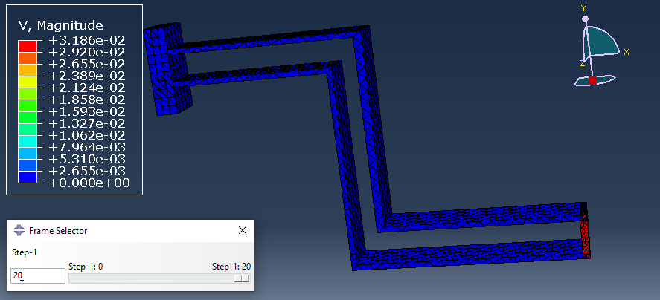

Figure 4-15 Velocity contour diagram at step 20

## 1-3 Stress diagram

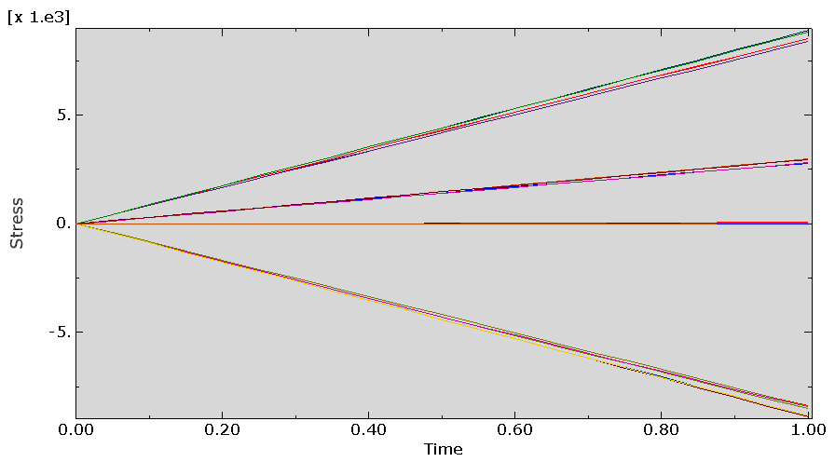

Figure 4-16 Stress diagram

## 1-4 Bending diagram

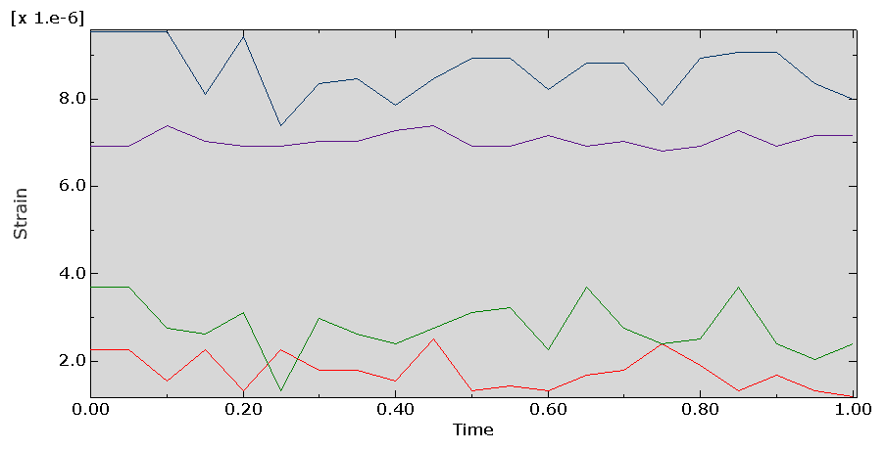

Figure 4-17 Bending diagram

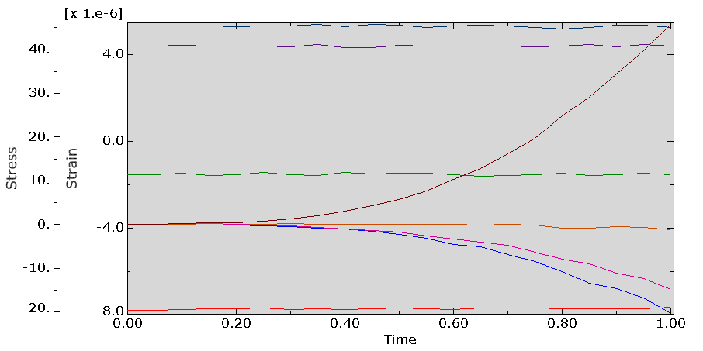

Figure 4-17 Stress and bending diagram

# Chapter Five Conclusion

## 1-1Introduction

Through static load testing on four steel composite slabs , investigating the effects of varying the lap reinforcement length at the connection and the section height on the load - bearing capacity of composite slabs , along with numerical simulation and theoretical research , the following results can be obtained .​

## 1-2 Conclusion

The results are as follows:

(1) By setting different lengths of laps for reinforcement in the connection and comparing the test results , it is obvious that the logical increase of the lap length helps to increase the load - bearing capacity of composite slabs . However , when the lap length exceeds a certain threshold , its effect on the deflection resistance in the later stages becomes negligible .

(2) Placing lap reinforcement in the grooves of precast slabs , i.e. , increasing the effective height of the section where the joint reinforcement is located, delays the crack propagation speed and effectively controls the deflection of composite slabs , resulting in an increase in the flexural capacity of up to 92.3 % . This indicates a significant effect of changing the section height on improving the crack resistance and flexural performance .

( 3 ) The finite element model results agree well with the experimental data and confirm the accuracy of the finite element model in predicting the flexural capacity and crack propagation patterns of two - way composite beams under static loading conditions . The deviation between the simulation and experimental results is within 10 % .​​​​​​ It is .

( 4) By analyzing and analyzing the characteristics of the reinforcement anchor stress at the connection and the bending state at the composite surface of the slabs, the derived mechanical characteristics and the calculation formula for the critical bending moment of the composite slab connection can be calculated quickly and effectively . The ultimate bearing capacity of the critical deflection values obtained from the calculations are in good agreement with the experimental values and provide a reference for engineering design . However , a limitation arises from the assumption that the tensile stress on the steel gap surface is uniformly distributed and reaches the axial tensile strength of the steel . This ideal stress distribution may not be fully realized in real conditions , especially in the presence of local stress concentrations .​​​​​​​

Furthermore , while this study focuses on the flexural performance and crack resistance of composite slabs , future research should investigate the geometric configurations of composite slab designs and their effects on load - bearing capacity , and also investigate the role of different reinforcing materials ( such as high - strength steel or fiber - reinforced materials ) in enhancing the load - bearing performance of the connection . This will facilitate wider applications of the findings in engineering practice .​​​​​​​​​​​

# Resources

[1] Develi, K. Computation of direction dependent joint surface parameters through the algorithm of triangular prism surface area method: A theoretical and experimental study. Int. J. Solids Struct. 2020, 202, 895–911.

[2] Xie, H.; Zhu, J.; Zhou, T.; Zhang, K.; Zhou, C. Conceptualization and preliminary study of engineering disturbed rock dynamics. Geomech. Geophys. Geo-Energy Geo-Resource. 2020, 6, 34.

[3] Han, Z.; Li, D.; Li, X. Dynamic mechanical properties and wave propagation of composite rock-mortar specimens based on SHPB tests. Int. J. Min. Sci. Technol. 2022, 32, 793–806.

[4] Han, Z.; Li, D.; Li, X. Effects of axial pre-force and loading rate on Mode I fracture behavior of granite. Int. J. Rock Mech. Min. Sci. 2022, 157, 105172.

[5] Xie, SJ; Han, ZY; Chen, YF; Wang, YX; Zhao, YL; Lin, H. Constitutive modeling of rock materials considering the void compaction characteristics. Arch. Civ. Mech. Eng. 2022, 22, 60.

[6] Wen, GP; Hu, JH; Jie, W.; Yang, DJ; Rui, X. Characteristics of stress, crack evolution, and energy conversion of anchored granite containing two preexisting fissures under uniaxial compression. Bull. Eng. Geol. Environment. 2023, 82, 1–14.

[7] Xie, HP; Sun, HQ; Ju, Y.; Feng, ZG Study on generation of rock fracture surfaces by using fractal interpolation. Int. J. Solids Struct. 2001, 38, 5765–5787.

[8] Singh, HK; Basu, A. Evaluation of existing criteria in estimating shear strength of natural rock discontinuities. Eng. Geol. 2018, 232, 171–181.

[9] Elmo, D.; Donati, D.; Stead, D. Challenges in the characterization of intact rock bridges in rock slopes. Eng. Geol. 2018, 245, 81–96.

[10] Yu, WJ; Li, K.; Liu, Z.; An, BF; Wang, P.; Wu, H. Mechanical characteristics and deformation control of surrounding rock in weakly cemented siltstone. Environment. Earth Sci. 2021, 80, 1–5.

[11] Asadizadeh, M.; Hossaini, MF; Moosavi, M.; Masoumi, H.; Ranjith, PG Mechanical characterization of jointed rock-like material with non-persistent rough joints subjected to uniaxial compression. Eng. Geol. 2019, 260, 105224.

[12] Salmi, EF; Nazem, M.; Karakus, M. Numerical analysis of a large landslide induced by coal mining subsidence. Eng. Geol. 2017, 217, 141–152.

[13] Lin, QB; Cao, P.; Wen, GP; Meng, JJ; Cao, RH; Zhao, ZY Crack coalescence in rock-like specimens with two dissimilar layers and pre-existing double parallel joints under uniaxial compression. Int. J. Rock Mech. Min. Sci. 2021, 139, 104621.

[14] Cai, WQ; Zhu, HH; Liang, WH Three-dimensional tunnel face extrusion and reinforcement effects of underground excavations in deep rock masses. Int. J. Rock Mech. Min. Sci. 2022, 150, 104999.

[15] Liu, J.; Wang, J. Numerical study of crack propagation in an indented rock specimen. Comput. Geotech. 2018, 96, 1–11.

[16] Han, Z.; Li, D.; Zhou, T.; Zhu, Q.; Ranjith, PG Experimental study of stress wave propagation and energy characteristics across rock specimens containing cemented mortar joint with various thicknesses. Int. J. Rock Mech. Min. Sci. 2020, 131, 104352.

[17] Chen, W.; Wan, W.; Zhao, YL; Peng, WQ Experimental study of the crack predominance of rock-like material containing parallel double fissures under uniaxial compression. Sustainability 2020, 12, 5188.

[18] Zheng, CS; Jiang, BY; Xue, S.; Chen, ZW; Li, H. Coalbed methane emissions and drainage methods in underground mining for mining safety and environmental benefits: A review. Process. Saf. Environment. 2019, 127, 103–124.

[19] Sow, D.; Carvajal, C.; Breul, P.; Peyras, L.; Rivard, P.; Bacconnet, C.; Ballivy, G. Modeling the spatial variability of the shear strength of discontinuities of rock masses: Application to a dam rock mass. Eng. Geol. 2017, 220, 133–143.

[20] Zhou, X.; Xie, YJ; Long, GC; Li, JT Effect of surface characteristics of aggregates on the compressive damage of high-strength concrete based on 3D discrete element method. Construction Build. Mater. 2021, 301, 124101.

[21] Xie, S.; Lin, H.; Wang, Y.; Chen, Y.; Xiong, W.; Zhao, Y.; Du, S. A statistical damage constitutive model considering whole joint shear deformation. Int. J. Damage Mech. 2020, 29, 988–1008.

[22] Babanouri, N.; Asadizadeh, M.; Hasan-Alizade, Z. Modeling shear behavior of rock joints: A focus on interaction of influencing parameters. Int. J. Rock Mech. Min. Sci. 2020, 134, 104449.

[23] Xie, S.; Lin, H.; Cheng, C.; Chen, Y.; Wang, Y.; Zhao, Y.; Yong, W. Shear strength model of joints based on Gaussian smoothing method and macro-micro roughness. Comput. Geotech. 2022, 143, 104605.

[24] Xie, S.; Han, Z.; Zhou, T. A semiempirical constitutive relationship for rocks under uniaxial compression considering the initial damage recovery. Fatigue Fract. Eng. Mater. Struct. 2023, 46, 1300–1313.

[25] Zhu, CG; Long, SC; Zhang, JX; Wu, WH; Zhang, LY Time series multi-sensors of interferometry synthetic aperture radar for monitoring ground deformation. Front. Environment. Sci. 2022, 10, 952.

[26] Pirzada, MA; Bahaaddini, M.; Moradian, O.; Roshan, H. Evolution of contact area and aperture during the shearing process of natural rock fractures. Eng. Geol. 2021, 291, 106236.

[27] Renaud, S.; Bouaanani, N.; Miquel, B. Numerical simulation of experimentally shear-tested contact specimens from existing dam joints. Comput. Geotech. 2020, 125, 103630.

[28] Singh, HK; Basu, A. Shear behaviors of 'real' natural un-matching joints of granite with equivalent joint roughness coefficients. Eng. Geol. 2016, 211, 120–134.

[29] Saadat, M.; Taheri, A. A cohesive discrete element based approach to characterize the shear behavior of cohesive soil and clay-infilled rock joints. Comput. Geotech. 2019, 114, 103109.

[30] Xin, J.; Jiang, Q.; Liu, Q.; Zheng, H.; Li, SJ A shear constitutive model and experimental demonstration considering dual void portion and solid skeleton portion of rock. Eng. Fract. Mech. 2023, 281, 109066.

[31] Zhou, X.; Xie, YJ; Long, GC; Zeng, XH; Li, JT; Yao, L.; Jiang, WH; Pan, ZL DEM analysis of the effect of interface transition zone on dynamic splitting tensile behavior of high-strength concrete based on multi-phase model. Cem. Concr. Res. 2021, 149, 106577.

[32] Zhao, YL; Luo, SL; Wang, YX; Wang, WJ; Zhang, LY; Wan, W. Numerical analysis of karst water inrush and a criterion for establishing the width of water-resistant rock pillars. Mine Water Environ. 2017, 36, 508–519.

[33] Yuan, ZG; Zhao, JT; Li, SQ; Jiang, ZH; Huang, F. A unified solution for surrounding rock of roadway considering seepage, dilatancy, strain-softening and intermediate principal stress. Sustainability 2022, 14, 8099.

[34] Wu, H.; Jia, Q.; Wang, WJ; Zhang, N.; Zhao, YM Experimental test on nonuniform deformation in the tilted strata of a deep coal mine. Sustainability 2021, 13, 13280.

[35] Xie, S.; Han, Z.; Hu, H.; Lin, H. Application of a novel constitutive model to evaluate the shear deformation of discontinuity. Eng. Geol. 2022, 304, 106693.

[36] Zou, SH; Li, K.Q.; Han, QY; Yu, CW Numerical simulation of the dynamic formation process of fog-haze and smog in transport tunnels of a hot mine. Indoor Built Environment. 2017, 26, 1062–1069.

[37] Sun, Z.; Niu, DT; Wang, XQ; Zhang, L.; Luo, DM Bond behavior of coral aggregate concrete and corroded Cr alloy steel bar. J. Build Eng. 2022, 61, 105294.

[38] Sun, Z.; He, WD; Niu, DT; Zhang, L.; Su, L.; Wang, XQ Resistivity prediction model for basalt-polypropylene fiber-reinforced concrete. Buildings 2023, 13, 84.

[39] Haghgouei, H.; Kargar, AR; Amini, M.; Esmaeili, K. An analytical solution for analysis of toppling-slumping failure in rock slopes. Eng. Geol. 2020, 265, 105396.

[40] Wu, YQ; Zhou, YS Hybrid machine learning model and Shapley additive explanations for compressive strength of sustainable concrete. Construction Build. Mater. 2022, 330, 127298.

[41] Wu, YQ; Zhou, YS Prediction and feature analysis of punching shear strength of two-way reinforced concrete slabs using optimized machine learning algorithm and Shapley additive explanations. Mech. Adv. Mater. Struc. 2022.

[42] Lin, QB; Cao, P.; Meng, JJ; Cao, RH; Zhao, ZY Strength and failure characteristics of jointed rock mass with double circular holes under uniaxial compression: Insights from discrete element modeling method. Theor. Appl. Fract. Mec. 2020, 109, 102692.

[43] Thirukumaran, S.; Indraratna, B. A review of shear strength models for rock joints subjected to constant normal stiffness. J. Rock Mech. Geotech. Eng. 2016, 8, 405–414.

[44] Zhao, YL; Tang, JZ; Chen, Y.; Zhang, LY; Wang, WJ; Wan, W.; Liao, JP Hydromechanical coupling tests for mechanical and permeability characteristics of fractured limestone in complete stress-strain process. Environment. Earth Sci. 2017, 76, 1–18.

[45] Patton, FD Multiple modes of shear failure in rock. In Proceedings of the 1st Congress of International Society of Rock Mechanics, Lisbon, Portugal, 25 September–1 October 1966.

[46] Cai, W.; Zhu, H.; Liang, W. Three-dimensional stress rotation and control mechanism of deep tunneling incorporating generalized Zhang–Zhu strength-based forward analysis. Eng. Geol. 2022, 308, 106806.

[47] Zhao, YL; Zhang, CS; Wang, YX; Lin, H. Shear-related roughness classification and strength model of natural rock joint based on fuzzy comprehensive evaluation. Int. J. Rock Mech. Min. Sci. 2021, 137, 104550.

[48] Barton, N.; Choubey, V. The shear strength of rock joints in theory and practice. Rock Mech. 1977, 10, 1–54.

[49] Ulusay, R. The ISRM Suggested Methods for Rock Characterization, Testing and Monitoring: 2007–2014; Springer: Berlin/Heidelberg, Germany, 2014.

[50] Xie, S.; Lin, H.; Duan, H. A novel criterion for yield shear displacement of rock discontinuities based on renormalization group theory. Eng. Geol. 2023, 314, 107008.

[51] Xie, S.; Lin, H.; Chen, Y. New constitutive model based on disturbed state concept for shear deformation of rock joints. Arch. Civ. Mech. Eng. 2022, 23, 26.

[52] Li, Y.; Oh, J.; Mitra, R.; Hebblewhite, B. A constitutive model for a laboratory rock joint with multi-scale asperity degradation. Comput. Geotech. 2016, 72, 143–151.

[53] Oh, J.; Cording, EJ; Moon, T. A joint shear model incorporating small-scale and large-scale irregularities. Int. J. Rock Mech. Min. Sci. 2015, 76, 78–87.

[54] Zhao, YL; Liu, Q.; Zhang, CS; Liao, J.; Lin, H.; Wang, YX Coupled seepage-damage effect in fractured rock masses: Model development and a case study. Int. J. Rock Mech. Min. Sci. 2021, 144, 104822.

[55] Feng, WL; Zou, DJ; Wang, T.; Qiao, CS; Xu, SF Study on a nonlinear shear damage constitutive of structural plane and application of discrete element. Comput. Geotech. 2023, 155, 105190.

[56] Parrinello, F.; Failla, B.; Borino, G. Cohesive–frictional interface constitutive model. Int. J. Solids Struct. 2009, 46, 2680–2692.

[57] Cai, W.; Zhu, H.; Liang, W.; Wang, X.; Su, C.; Wei, X. A post-peak dilatancy model for soft rock and its application in deep tunnel excavation. J. Rock Mech. Geotech. Eng. 2023, 15, 683–701.

[58] Tong, D.; Yi, X.-W.; Tan, F.; Jiao, YY; Liang, J. Three-dimensional numerical manifold method for heat conduction problems with a simplex integral on the boundary. Sci. China Technol. Sci. 2023.

[59] Leong, EC; Randolph, MF A model for rock interfacial behavior. Rock Mech. Rock Eng. 1992, 25, 187–206.

[60] Goodman, R. The mechanical properties of joints. In Proceedings of the 3rd Int Congr International Society of Rock Mechanics, Denver, CO, USA, 1–7 September 1974; pp. 1–7.

[61] Xiao, W.; Dui, G.; Chen, T.; Ren, Q. A study of constitutive model coupling dilatancy and degradation for jointed rock. Chin. J. Rock Mech. Eng. 2009, 28, 2535–2543.

[62] Sun, W.; Gao, J.; Zhang, W.; Yang, K. Experimental study on the shear mechanical properties of discontinuities in rock masses. China Water Transp. 2008, 8, 159–160.

[63] Lee, S. Stability around underground Openings in Rock with Dilative, Non-Persistent and Multi-Scale Wavy Joints Using a Discrete Element Method; University of Illinois at Urbana-Champaign: Chicago, IL, USA, 2003.

[64] Xu, L.; Ren, Q. A new constitutive model for rock discontinuities. Rock Soil Mech. 2011, 32, 217–224.

[65] Gens, A.; Carol, I.; Alonso, EE A constitutive model for rock joints formulation and numerical implementation. Comput. Geotech. 1990, 9, 3–20.

[66] Kulhawy, FH Stress deformation properties of rock and rock discontinuities. Eng. Geol. 1975, 9, 327–350.

[67] Bandis, SC; Lumsden, AC; Barton, NR Fundamentals of rock joint deformation. Int. J. Rock Mech. Min. Sci. 1983, 20, 249–268.

[68] Xie, S.; Lin, H.; Chen, Y.; Yong, R.; Xiong, W.; Du, S. A damage constitutive model for shear behavior of joints based on determination of the yield point. Int. J. Rock Mech. Min. Sci. 2020, 128, 104269.

[69] Xie, S.; Han, Z.; Shu, R.; Chen, Y.; Feng, F. A new method to determine the crack closure stress based on stress difference. Theor. Appl. Fract. Mec. 2022, 119, 103337.

[70] Xie, SJ; Lin, H.; Wang, YX; Cao, RH; Yong, R.; Du, SG; Li, JT Nonlinear shear constitutive model for peak shear-type joints based on improved Harris damage function. Arch. Civ. Mech. Eng. 2020, 20, 1–14.

[71] Papaliangas, T.; Hencher, SR; Lumsden, AC; Manolopoulou, S. The effect of frictional fill thickness on the shear strength of rock discontinuities. Int. J. Rock Mech. Min. Sci. 1993, 30, 81–91.

[72] Grasselli, G. Manuel Rocha Medal recipient-Shear strength of rock joints based on quantified surface description. Rock Mech. Rock Eng. 2006, 39, 295–314.

[73] Nasir, O.; Fall, M. Shear behavior of cemented pastefill-rock interfaces. Eng. Geol. 2008, 101, 146–153.

[74] Bahaaddini, M. Effect of boundary condition on the shear behavior of rock joints in the direct shear test. Rock Mech. Rock Eng. 2017, 50, 1141–1155.

[75] Ge, YF; Tang, HM; Eldin, M.; Wang, LQ; Wu, Q.; Xiong, CR Evolution process of natural rock joint roughness during direct shear tests. Int. J. Geomech. 2017, 17, E4016013.

[76] Ong, DEL; Choo, CS Assessment of non-linear rock strength parameters for the estimation of pipe jacking forces. Part 1. Direct shear testing and back analysis. Eng. Geol. 2018, 244, 159–172.

[77] Zhao, ZH; Dou, ZH; Xu, HR; Liu, ZN Shear behavior of Beishan granite fractures after thermal treatment. Eng. Fract. Mech. 2019, 213, 223–240.

[78] Zhou, H.; Cheng, GT; Zhu, Y.; Chen, J.; Lu, JJ; Cui, GJ; Yang, PQ Experimental study of shear deformation characteristics of marble dentate joints. Rock Soil Mech. 2019, 40, 852–860.

[79] Wang, F.; Xia, K.; Yao, W.; Wang, S.; Wang, C.; Xiu, Z. Slip behavior of rough rock discontinuity under high velocity impact: Experiments and models. Int. J. Rock Mech. Min. Sci. 2021, 144, 104831.

[80] Fan, X.; Deng, ZY; Cui, ZM; He, ZM; Lin, H. A new peak shear strength model for soft-hard joint. Rock Soil Mech. 2021, 42, 1861–1870.

[81] Bao, H.; Xu, X.; Lan, H.; Yan, C.; Xu, J. Stiffness model of rock joint by considering anisotropic morphology. J. Traffic Transp. Eng. 2021, 11, 1–18.